Distributed Secret Sharing Approach with Cheater Prevention based on QR Code

1. K.Ruthra Priya | 2. Mrs. Shyamala Devi MCA, M.E | 3. J.Keerthana
Student | Asst.Prof | Student
Easwari Engineering College  Chennai | Easwari Engineering College  Chennai | Easwari Engineering College  Chennai
ruthra.karanthilak@gmail.com | shyamaladevi@gmail.com | keerthanajagannathan.24@gmail.com

ABSTRACT--This project is to propose a real time capturing of a system using a Quick Response code in an android smart phone. The concept of e-voting application is created using an android phone. The authentication is done through the scanning of QR code via the mobile scanner application. The voter has to register using the application and the QR code will be provided when the admin accepts the voter based on the voter details. In this method the voter details are made to hide in the QR code, using multiplexing and DE multiplexing process encode and decode the information from single QR code with special symbols and split the data back to their QR code pattern.

Key terms—real time capturing, QR code, special symbols.

- INTRODUCTION
QR code (abbreviated from Quick Response Code) is the trademark for a type of matrix barcode (or two-dimensional barcode) first designed for the automotive industry in Japan. A barcode is a machine-readable optical label that contains information about the item to which it is attached. A QR code uses four standardized encoding modes (numeric, alphanumeric, byte/binary, and kanji) to efficiently store data; extensions may also be used.
The QR code system became popular outside the automotive industry due to its fast readability and greater storage capacity compared to standard UPC barcodes. Applications include product tracking, item identification, time tracking, document management, and general marketing.
A QR code consists of black squares arranged in a square grid on a white background, which can be read by an imaging device such as a camera, and processed using Reed–Solomon error correction until the image can be appropriately interpreted. The required data is then extracted from patterns that are present in both horizontal and vertical components of the image.
The proper execution of democratic rights has become linked to the availability and reliable functioning of advanced information and communication technology (ICT). While modern societies fully rely on ICT for business, work and leisure time activities, the use of ICT for democratic decision making is still in its infancy. In fact, the out date technological concepts for voting have been blamed in part for lost and uncounted votes and could therefore be responsible for biased political decisions making. Countries all over the world are examining e-voting, for it has some striking advantages over traditional paper voting, including security for casting votes, accuracy of counting and analyzing votes, options to conduct voting in a centralized and decentralized manner, etc. The reasons why the e-voting technology has not matured to equivalent levels as known for business and leisure time activities lies mostly in an inherent lack of trust and fear of electronic threats. While most countries are still conceptualizing or testing e-voting systems, three cantons in Switzerland have pioneered the development of e-voting to its full technological maturity. The world is always in improvement and growth in technology, that's why we should go parallel with it, to be able as much as we can get benefit from these improvements.
- OBJECTIVES
- To overcome the existing method of e-voting which uses concept like bio-metrics, sms voting, etc.
- In the proposed method the concept of e-voting application is created using android.
- The authentication is done through the scanning of QR-Code through the mobile scanner application.
- In this method the voter has to register using the application and the QR-Code will be provided once the registration is successful.
- On scanning the QR-Code the voter will be asked for the password.
- Once the authentication is done the voter is made to proceed with the voting process.
- The main purpose of implementing this concept is to increase the voting percentage.
- So that the voter is not required to visit the voting centre to cast their vote and also to avoid fake voting.
- EXISTING SYSTEM

Existing System is the one in which the biometric concept is used where the scanning of finger print is done. For some people it is very intrusive, because is still related to criminal identification. Voters can’t able to come and cast their vote from their working location to native. Queue system get too late for voters to vote.
Disadvantages of this system are as follows:
- System is little bit complex
- Less security.
- Hacking voter results.
- Time Delay.
- Cost Effective.
- Time consumption is high.

- PROPOSED SYSTEM

System resides in the new concept of QR-Code and Scanner Application. Candidate details made to hide in the QR-Code. Through scanner application the QR-Code is scanned and details are retrieved. Here there is no chance of increasing the vote count. Then the voting is performed. In the proposed system, we are using QR code for recognizes image codes using smart phones to provide various services that can recognize the authenticity of any voter details. QR code verifies voter_id no by capturing it through the smart phone, then decodes and sends it to the server for authentication. This forwards the selected voter_id number list to the server and the response received from the server enables the consumer to decide based on the voter authenticity. Finally the election server, administrator will sort out the final result by checking the given information with already desired information.

- ALGORITHMS USED:

- Hamming code algorithm:
In this section our underlying graph is the binary Hamming space, i.e., a graph with the vertex set V = Fn2 and there is an edge between any two vertices x and y of Fn2 if x and y differ in exactly one coordinate. As usually, the vertices of Fn2 are called words and d(x, y), where x, y ∈ Fn2 ,is the Hamming distance, that is, the number of coordinates where the two words differ. Denote by V (n, t) the size of the Hamming ball in Fn2 of radius t. We define the support of a word x = (x1, . . . , xn) ∈ Fn2 by supp(x) = {i | xi = 0} and weight of x by w(x) = |supp(x)|. Denote by ei , i = 1, . . . , n, a wordsuch that there is 1 in the coordinate i and 0 elsewhere. The all zero-word is denoted by 0 = 00 . . . 0 and the all-one word by 1 = 11 . . . 1

- Binarization algorithm:
Binarization of gray scale images is the first and important step to be carried out in pre-processing system. Selecion of a proper binarization method is critical to the performance for recognition system.binarization algorithms that require a priori knowledge of the full image and large execution time. Then caculate the gray histogram for each block, and sort the gray value. The middle value is choosed as the threshold of each block. Finally the smallest value of these middle values is the global threshold of this whole image.

Advantages of this system are:
- Highly secured and there is no chance to revote.
- Scanning recognition.
- Real time tracking of results.
- Time consumption is less.
- No chance for hacking the votes
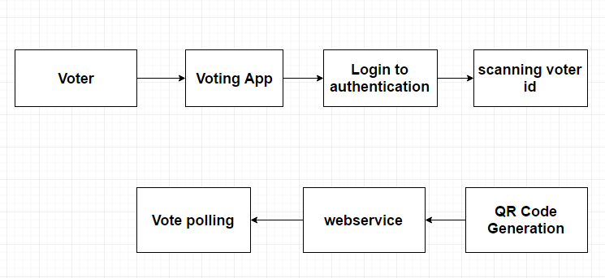
Fig:3.1 Generating QR code

- SYSTEM IMPLEMENTATION

- MODULE DESCRIPTION
Module1- Generating QR-Code Image:
In this module we are creating QR Code for encoding the information about the voter. The voter details contains voter_id no, voter_name, DoB, Address . Each pattern is encoded and represented each module in QR Code with black and white special symbols.QR-Code can hold information more than other bar codes.
Module2-Mobile Authentication Module
This module represents the authentication, which is used for the voter to login their details for the voting processes. Logged voter is redirected to the scanner module.
Module3- QR-Code Scanner Module
This module is used to scan the QR-Code and read the value of the QR-Code inside the mobile. QR-Code is a matrix bar code designed to be read by Smartphone.

Module4- Web Service Client Module
This module has the process of storing the selected candidate information from the client, which are send through the web service. All these informations will be stored in the database.
2. GENERATING QR CODE IMAGE:
In this module are creating qr codes for encoding the information about the products. The product contains name, code, quantity and price. Each pattern is encoded and represented each module in qr code with black and white special symbols. Qr code can hold information more than other bar codes. The format of QR Code includes unique Finder Pattern (Position Detection Patterns) located at three corners of the symbol and can be used to locate the positioning of the symbol, size and inclination.
Fig:3.2 Generating QR code

3. MOBILE AUTHENTICATION MODULE
This module represents the authentication, which is used for the customer to login their details for the shopping processes. Logged user is redirected to the scanner module. Authentication is used as the basis or authorization determining whether a privilege will be granted to a particular user or process. The validation process is done on the web server.
Fig:3.3MobileAuthentications

4. QR CODE SCANNER MODULES
This module is used to scan the QR code and read the value of the QR code inside the mobile. QR code is a matrix bar code designed to be read by Smartphone. The code contains of black modules arranged in a square pattern on a white background.The information encoded may be text, a URL, or other data. If the user selects the product, the details will directly forward to the server.
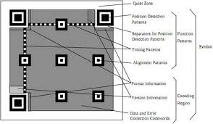
Fig: 3.4 QR code Scanner
- WEB SERVICE CLIENT MODULE
This module has the process of storing the selected product’s information from the client, which are send through the web service. All theseinformation will be stored in the database. We are maintaining a centralized server in order to receive the selected product list from the customer through internet. In this module the merchant see the ordered items from the client. The Merchant will use this list to do delivery the items to the customers.

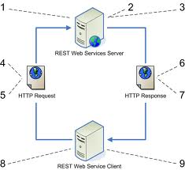
Fig: 6.5 Web service clients

- CONCLUSION
According to this project a real time system for Voting using Quick Response (QR) code in Android Smartphone is developed. QR code verifies products by capturing it through the smart phone, then decodes and sends it to the server for authentication. The Voter forwards the selected Candidate to the server and the response received from the server enables the Voter to decide based on the Candidates authenticity. An interesting future study might involve to simulate voting method at different gateway.

- REFERENCE:

- [1].E. Yaakobi and J. Bruck, “On the uncertainty of information retrieval in associative memories,” in Proc. IEEE Int. Symp. Inf. Theory, Jul. 2012, pp. 106–110.
- [2].Sartid Vongpradhip and Suppat Rungraungsilp, "QR Code Using Invisible Watermarking in Frequency Domain", 9th International conference on ICT and Knowledge Engineering, pp. 47-52, 2012.
- [3] G. Exoo, T. Laihonen, and S. Ranto, “New bounds on binary identifying codes,” Discrete Appl. Math., vol. 156, no. 12, pp. 2250–2263, 2008.
- [4].J. Fridrich, T. Pevný, and J. Kodovský, “Statistically undetectable JPEG stenography: Dead ends challenges, and opportunities,” in Proc. 9th ACM Workshop Multimedia Security, Dallas, TX, USA, Sep. 2007, pp. 3–14.
- [5].T. Filler, J. Judas, and J. Fridrich, “Minimizing additive distortion in stenography using syndrome-trellis codes,” IEEE Trans. Inf. Forensics Security, vol. 6, no. 3, pp. 920–935, Sep. 2011.

